EXPERIMENT 5
Mark List Using Zoho One (SaaS)
Aim
To create and manage a student mark list using Zoho One (Software as a Service – SaaS) by storing student details, entering subject marks, calculating total marks, and displaying the results efficiently..
Procedure
- Sign in to Zoho One: Open the Zoho One website and log in using your credentials.
- Create an application: Open Zoho Creator and create a new application named Student Mark List.
- Create a form: Add a form with the following fields:
  - Student Name
  - Register Number
  - Department
  - Subject 1 Marks
  - Subject 2 Marks
  - Subject 3 Marks
  - Subject 4 Marks
  - Subject 5 Marks
- Enter student details: Create records for each student and enter their marks in the respective subject fields.
- Calculate total marks: Add a formula field to calculate the total marks.
Total = Subject 1 + Subject 2 + Subject 3 + Subject 4 + Subject 5
6. Calculate percentage: Use the formula:
Percentage = (Total Marks / 500) × 100
- Generate the mark list: Create a report to display student details.
- View and manage results: Save the records and view, edit, or export the mark list as required.

Implementation Input:
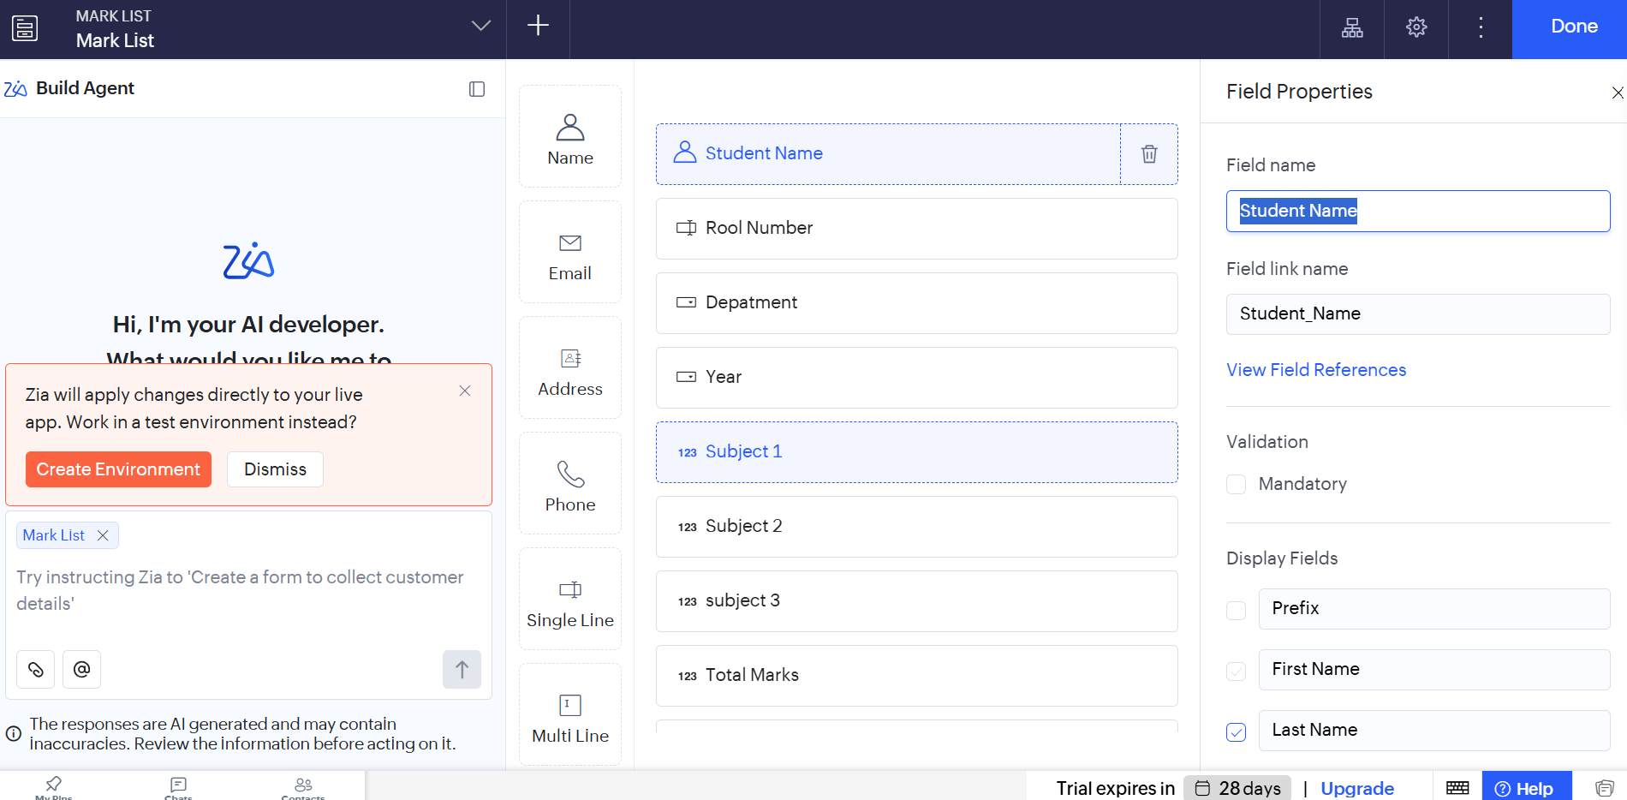
Output:
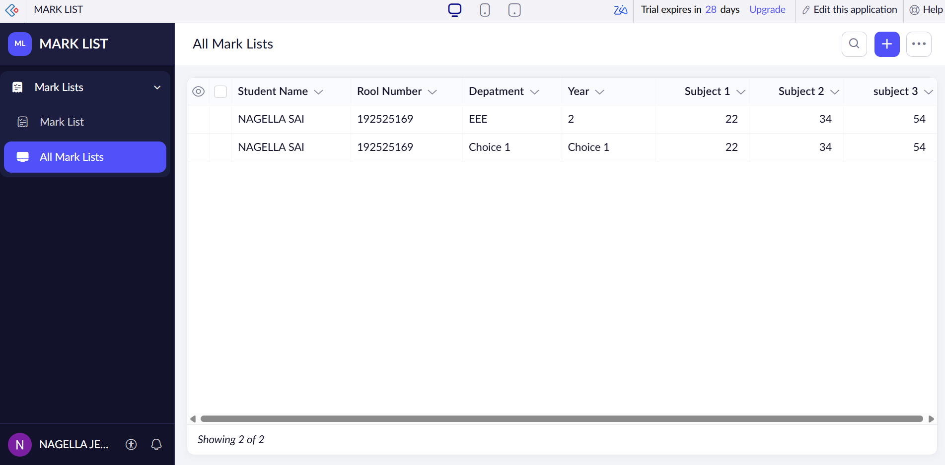

Result

Thus, a student mark list was created and managed using Zoho One (SaaS). Student details, subject marks, total marks, and percentages can be stored, calculated, and displayed efficiently using Zoho Creator.

